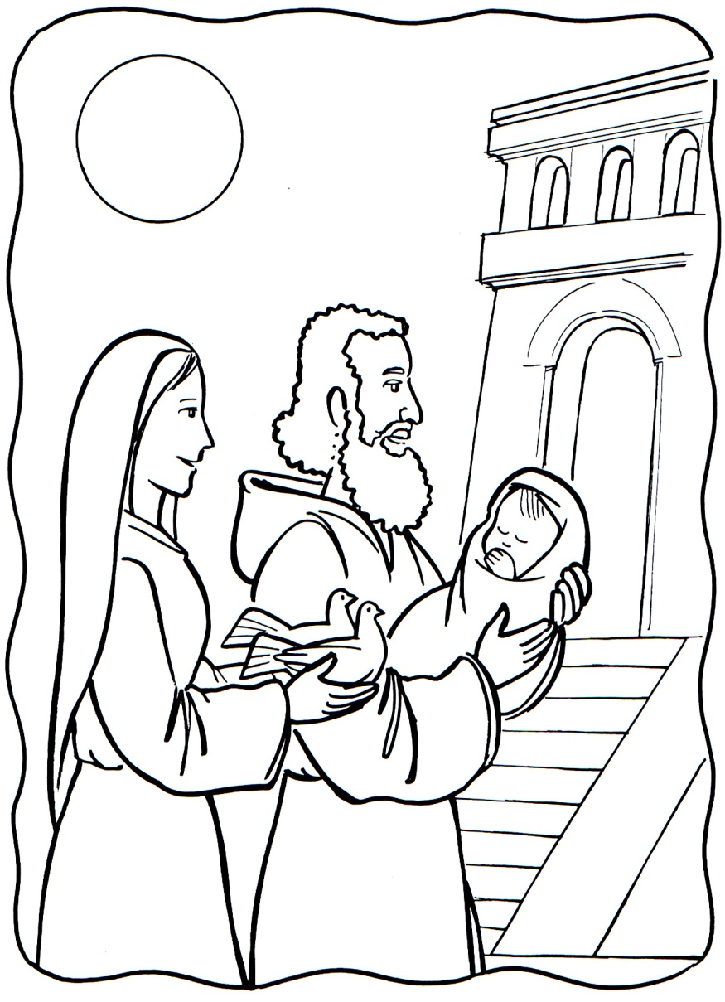
http://verbamanent.info/colorear-sime%F3n-y-ana#

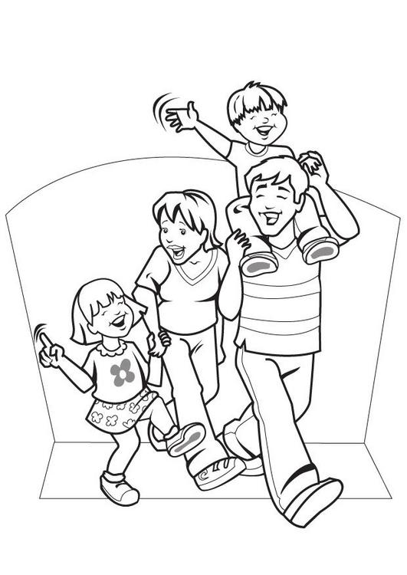
https://www.educima.com/dibujo-para-colorear-familia-i7089.html

