**sábado, 5 de julio de 2014**

**Van Gogh para niños.**

**Vídeos, dibujos para colorear.**

Fotografías y retratos de Vincent Van Gogh

[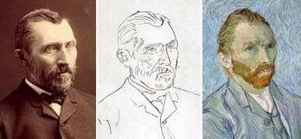](http://4.bp.blogspot.com/-2baTccjO3Zk/U7hMlTLZPLI/AAAAAAABJ9E/2asT3ewLl5Q/s1600/6a00d8341bfb1653ef00e54f80d51f8834-800wi.jpg)

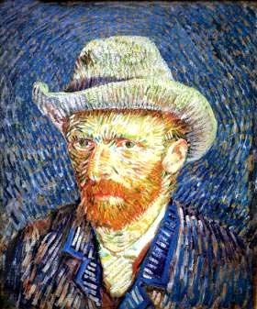  [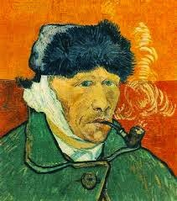](http://3.bp.blogspot.com/-Kk1UagUuTq0/U7hM029tNTI/AAAAAAABKBE/qDLZBJFTCk8/s1600/images+(2).jpg)

Cuadros de Van Gogh para colorear

[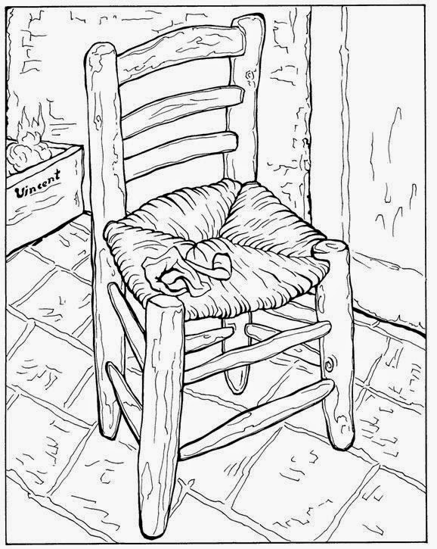](http://4.bp.blogspot.com/-Z71fWDXB2sg/U7hMl1205bI/AAAAAAABJ9I/5rT2tgZ4Au8/s1600/853ca3a07d62ccdf053529d7bfb5f73e.jpg)

[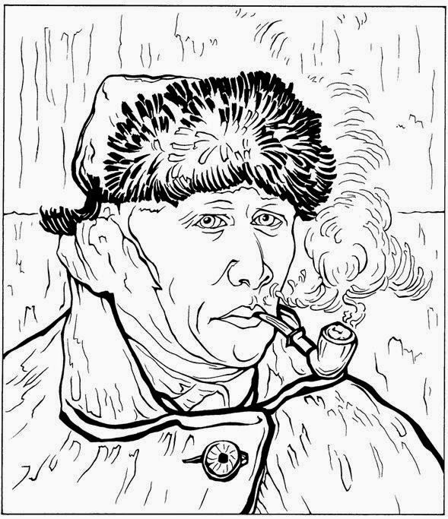](http://4.bp.blogspot.com/-llaQUm2sCC8/U7hMx4eEBZI/AAAAAAABKAM/L5TSYNLJpb0/s1600/Zelfportret+met+verband+1889.jpg)

[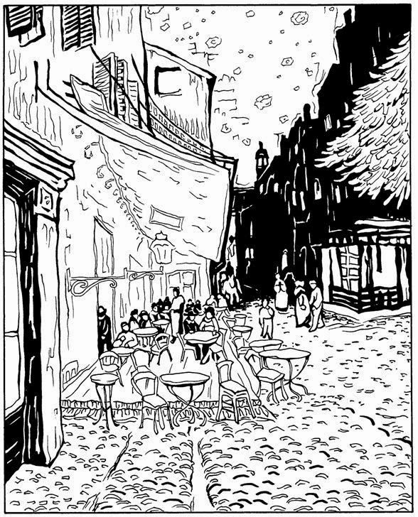](http://2.bp.blogspot.com/-60GF7Ofr04Q/U7hMnXRXazI/AAAAAAABJ9Y/hDU3Mfq1HcY/s1600/Caf%C3%A9terras+bij+nacht+1888.jpg)

[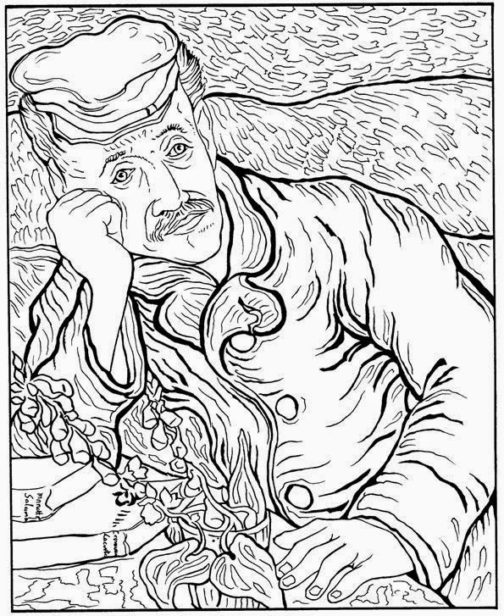](http://1.bp.blogspot.com/-0g3C1QzY_rE/U7hMnzduQRI/AAAAAAABJ9k/4eNwuEDP4No/s1600/Dokter+Gachet+1890.jpg)

[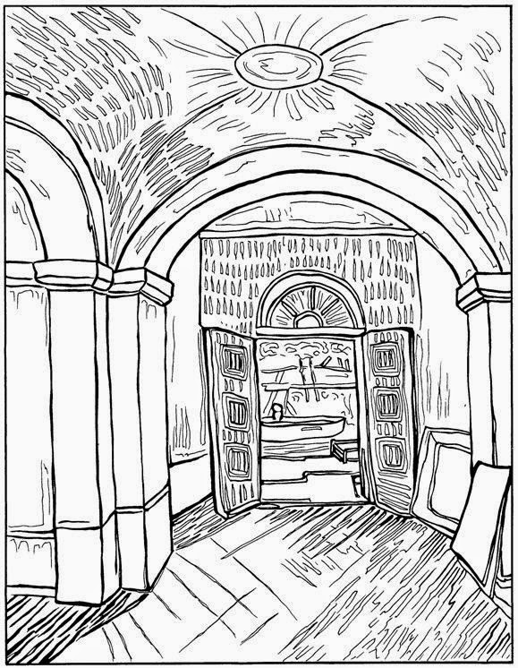](http://3.bp.blogspot.com/-wz9qse_NI8s/U7hMonzVIiI/AAAAAAABJ90/IDq1JvvrqbM/s1600/Ingang+Asylum+1889.jpg)

[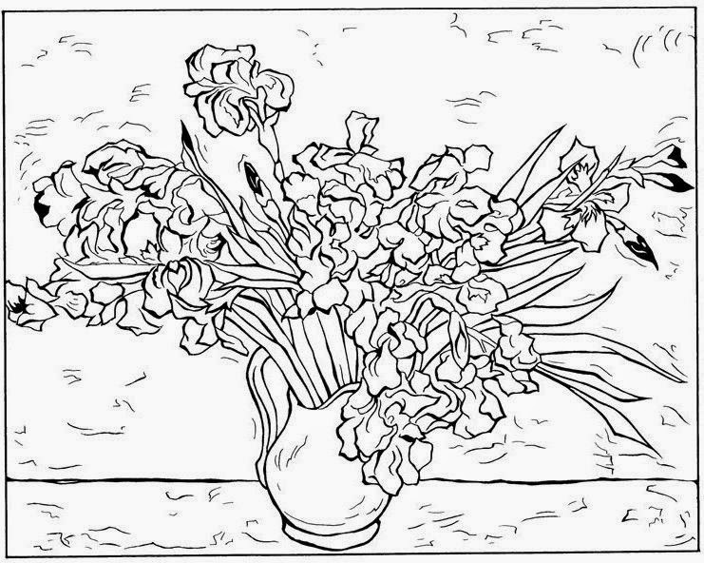](http://4.bp.blogspot.com/-HCUunrLjuoM/U7hMo2IjgFI/AAAAAAABJ94/iiEO8Cbbb4U/s1600/Irissen+1890.jpg)

[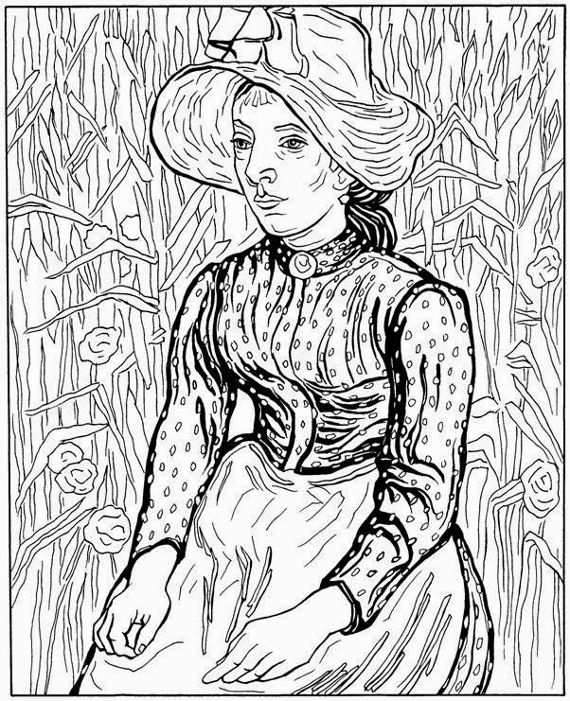](http://3.bp.blogspot.com/-8RNLH_ON7Bs/U7hMpOa9LlI/AAAAAAABJ98/gGvZNBEzHBM/s1600/Jonge+boerin+1890.jpg)

[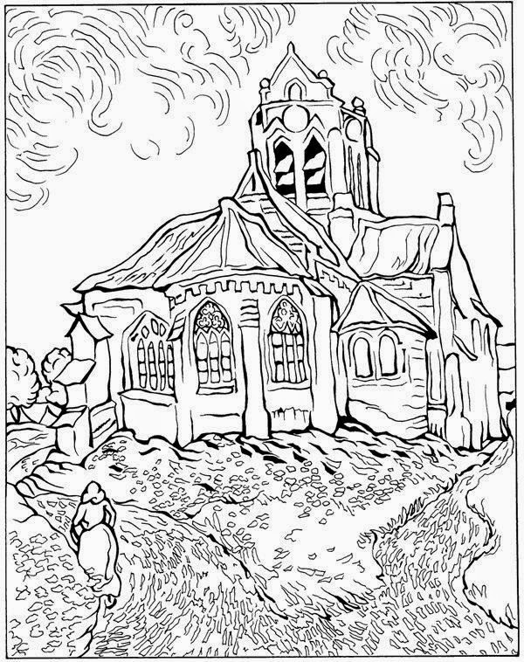](http://1.bp.blogspot.com/-ebLWVKDDT1Q/U7hMqP9dZuI/AAAAAAABJ-M/BDjz7wgyftg/s1600/Kerk+van+Auvers+1890.jpg)

[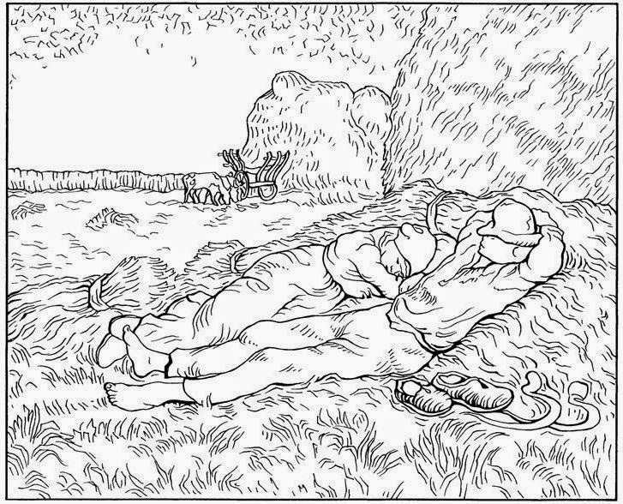](http://2.bp.blogspot.com/-k_QeV0RbheY/U7hMq5RMsoI/AAAAAAABJ-U/w6A42DPOjXY/s1600/Middag+Rust+1890.jpg)

[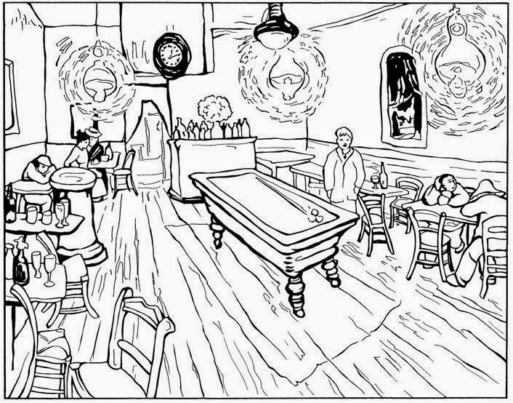](http://2.bp.blogspot.com/-jJlqfqeocCc/U7hMq9-qtkI/AAAAAAABJ-Y/7KndXXzD3WA/s1600/Nachtcaf%C3%A9+1888.jpg)

[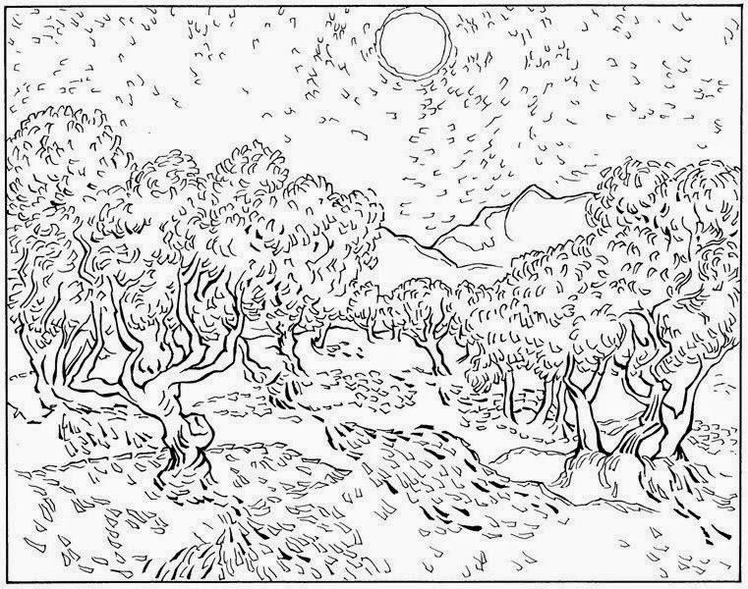](http://3.bp.blogspot.com/-LnYa9CDi1As/U7hMrAjHOVI/AAAAAAABJ-c/GjEw6HOXy3I/s1600/Olijf+bomen+1889.jpg)

[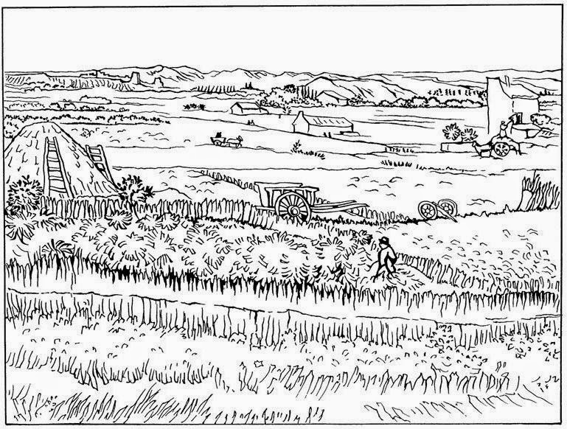](http://4.bp.blogspot.com/-PksTZ4H1yO0/U7hMr9MiqZI/AAAAAAABJ-w/rHU0Mu5IY3Y/s1600/Oogst+in+La+Crau+1888.jpg)

[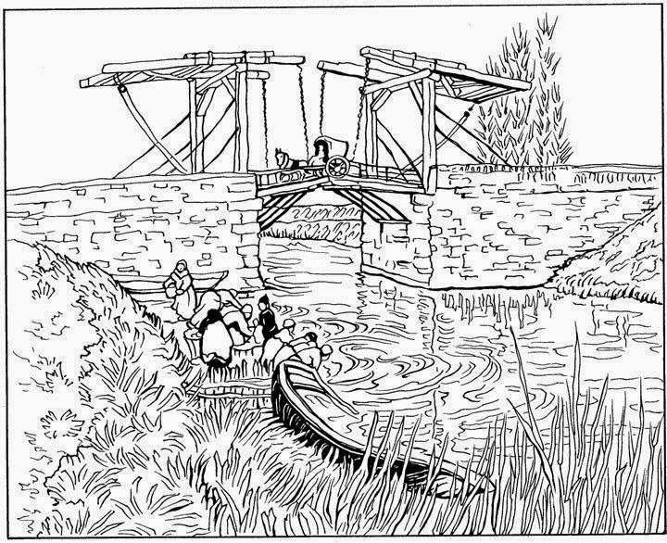](http://2.bp.blogspot.com/-E7MIwVT9-yI/U7hMsv420-I/AAAAAAABJ-4/VsRdxOj_o98/s1600/Ophaalbrug+bij+Arles+1888.jpg)

[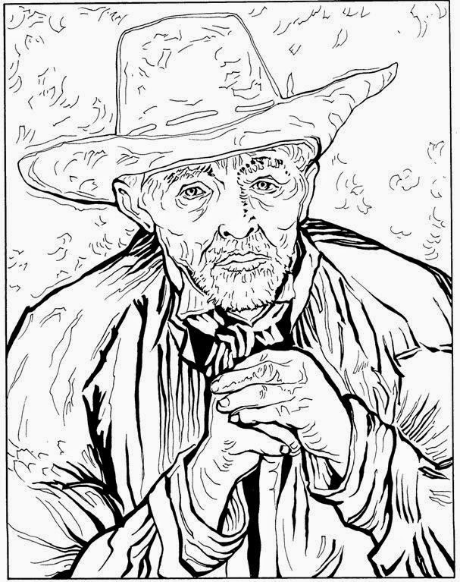](http://3.bp.blogspot.com/-7b6ha9BPB5k/U7hMslrYp1I/AAAAAAABJ-0/ZbqL1uVt9mM/s1600/Patience+Escalier+1888.jpg)

[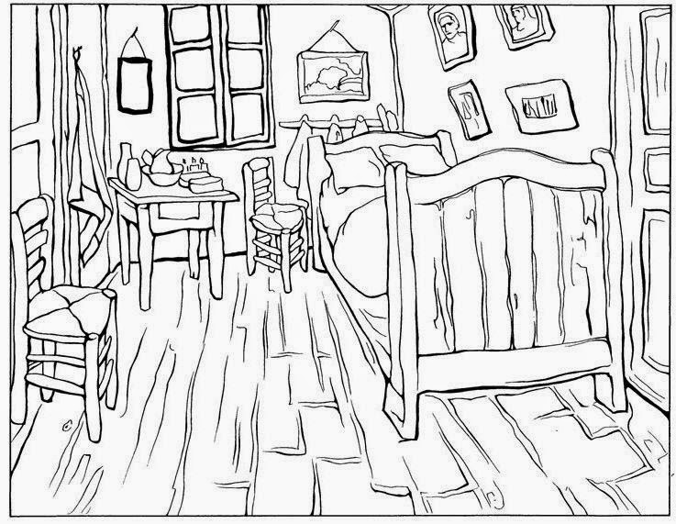](http://3.bp.blogspot.com/-HM-6CaH_dMw/U7hMtjRbg1I/AAAAAAABJ_I/io6saer7UNI/s1600/Slaapkamer+1888.jpg)

[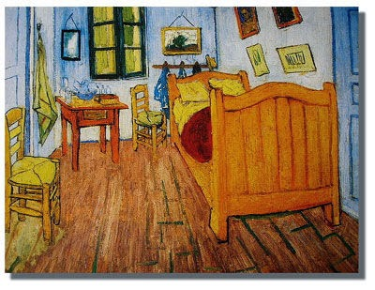](http://2.bp.blogspot.com/-rUG-33YKbs0/U7hM0LBPYbI/AAAAAAABKA4/Tk8TfTd3wo8/s1600/habitacion.jpg)

[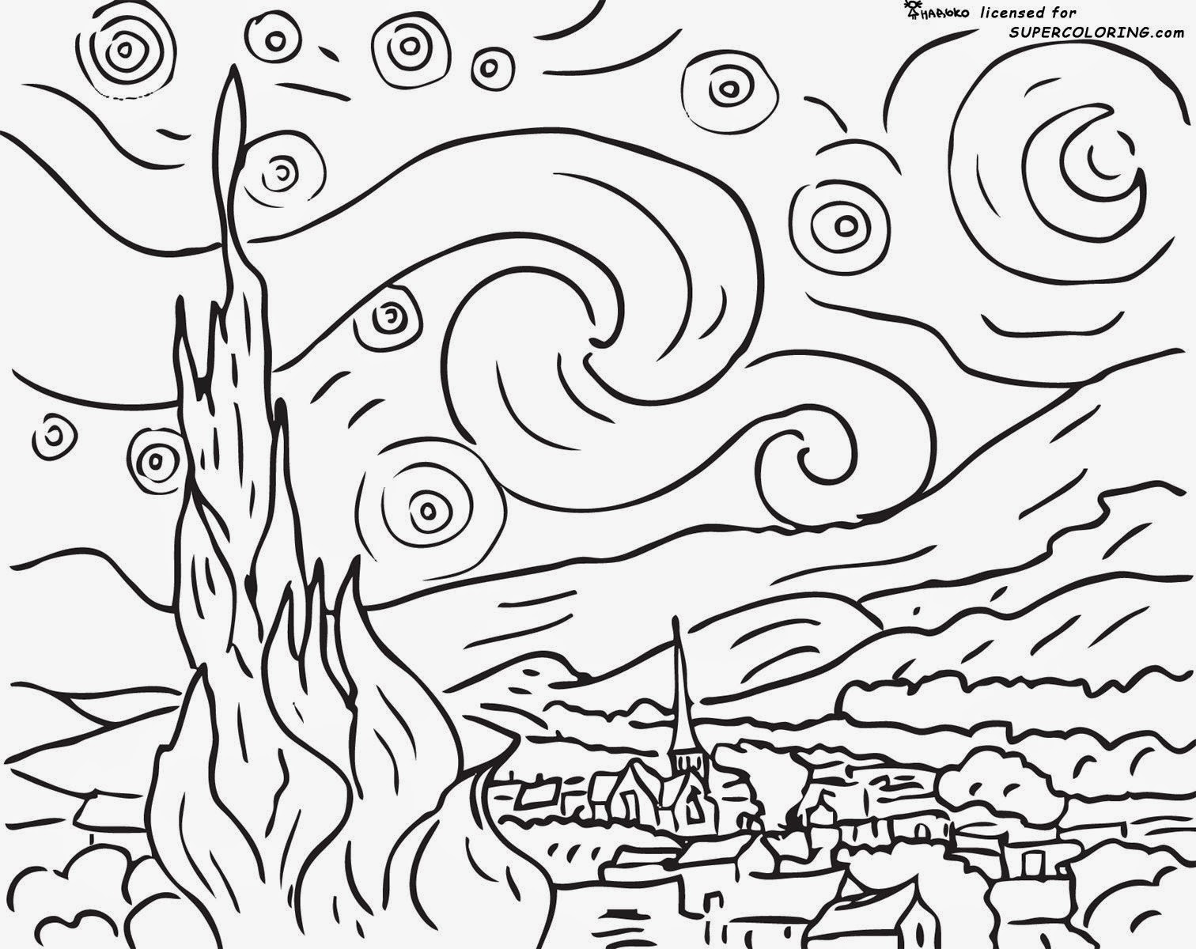](http://2.bp.blogspot.com/-IQJUF-qb-TA/U7hM20ZOe2I/AAAAAAABKB0/kD3P-0T4zUY/s1600/starry-night-by-vincent-van-gogh-coloring-page.jpg)

[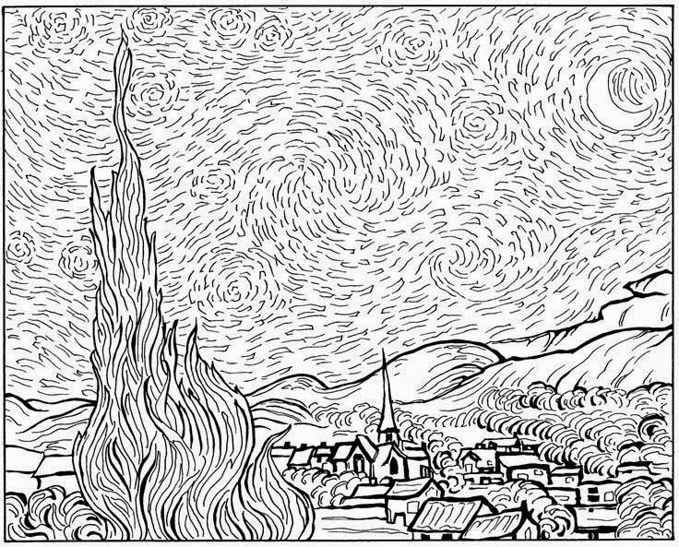](http://3.bp.blogspot.com/-pnF9_ZTQn-0/U7hMuJMDzHI/AAAAAAABJ_Q/uYZam1kBV7k/s1600/Sterren+1889.jpg)

[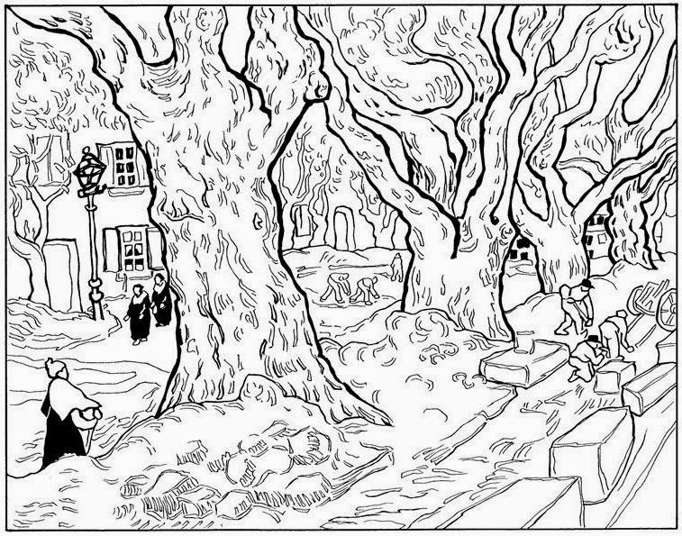](http://1.bp.blogspot.com/-MmgmpevALrM/U7hMvPL4jvI/AAAAAAABJ_c/god_5QLo5Ic/s1600/Stratenmakers+1889.jpg)

[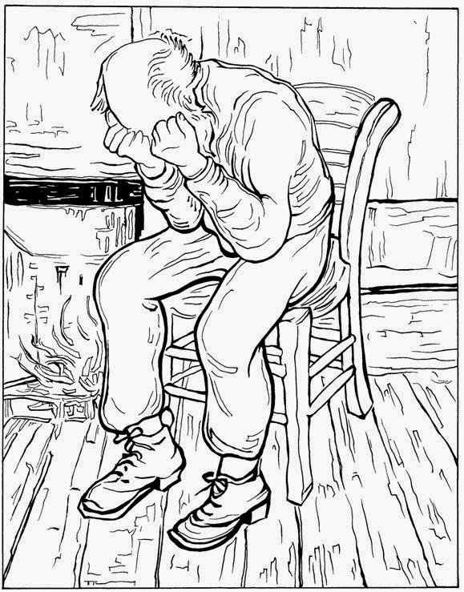](http://4.bp.blogspot.com/-3ZKh0yfv_O0/U7hMvDoC1kI/AAAAAAABJ_g/AAwYJGDxPys/s1600/Treurende+oude+man+1890.jpg)

[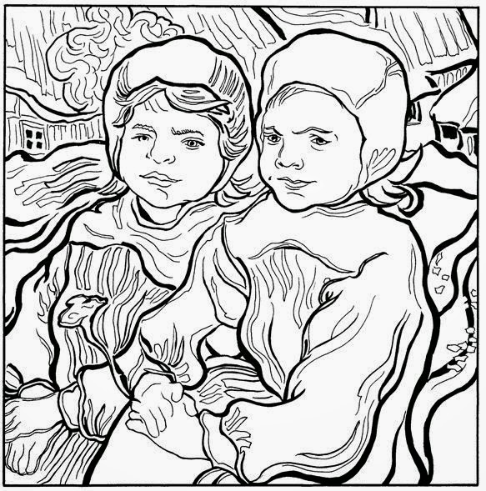](http://4.bp.blogspot.com/-PwToJMIIYR0/U7hMvecWe1I/AAAAAAABJ_k/N1eP_gEzi7I/s1600/Twee+kleine+meisjes+1890.jpg)