Ficha 8: Zona Norte Grande

Ejercitación:
Habilidad: Caracterizar la zona natural del Norte Grande considerando aspectos geográficos y político administrativos.

Escribe las regiones que forman parte del Norte Grande junto con sus capitales en los rectángulos (6 puntos)

Pinta la región de Arica – Parinacota de color Amarillo
Pinta la región de Tarapacá de color Anaranjado
Pinta la región de Antofagasta de color Café claro

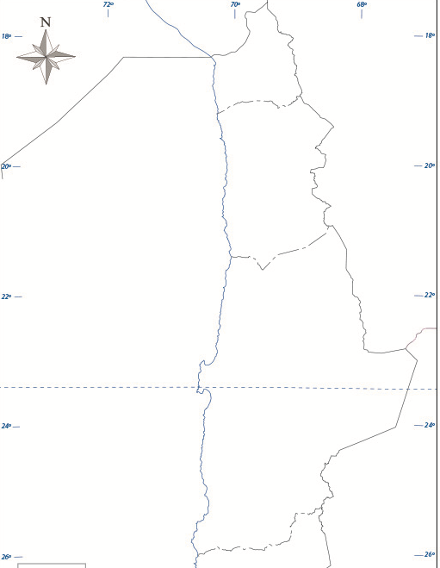

Complete el siguiente cuadro sinóptico con las características del Norte grande que se solicita:

Ámbito | Criterio | Característica de la Zona Norte
Clima | Clima (4 puntos) | __________________________________________________  __________________________________________________  __________________________________________________  __________________________________________________  __________________________________________________  __________________________________________________  __________________________________________________  __________________________________________________  __________________________________________________  __________________________________________________  __________________________________________________  __________________________________________________
Biodiversidad | Flora (4 puntos) | __________________________________________________  __________________________________________________  __________________________________________________  __________________________________________________  __________________________________________________  __________________________________________________  __________________________________________________
 | Fauna (4 puntos) | __________________________________________________  __________________________________________________  __________________________________________________  __________________________________________________  __________________________________________________  __________________________________________________  __________________________________________________
Relieve | Cordillera de los Andes (4 puntos) | __________________________________________________  __________________________________________________  __________________________________________________  __________________________________________________  __________________________________________________  __________________________________________________  __________________________________________________  __________________________________________________  __________________________________________________  __________________________________________________  __________________________________________________  __________________________________________________
 | Depresión Intermedia (4 puntos) | __________________________________________________  __________________________________________________  __________________________________________________  __________________________________________________
 | Cordillera de la Costa (4 puntos) | __________________________________________________  __________________________________________________  __________________________________________________  __________________________________________________
 | Planicies Litorales (4 puntos) | __________________________________________________  __________________________________________________  __________________________________________________  __________________________________________________
División político-administrativa | Región de Arica Parinacota (4 puntos) | Provincia | Capital
 | Región de Tarapacá (4 puntos) | Provincia | Capital
 | Región de Antofagasta (6 puntos) | Provincia | Capital

Evaluación Formativa
0 - 27 | VL | 28 - 35 | ML | 36 - 43 | L | 44 - 48 | TL

