Ficha 9: Zona Norte Chico

Ejercitación:
Habilidad: Caracterizar la zona natural del Norte Chico considerando aspectos geográficos y político administrativos.

Escribe las regiones que forman parte del Norte Chico junto con sus capitales en los rectángulos (4 puntos)

Pinta la región de Atacama de color Amarillo
Pinta la región de Coquimbo de color Anaranjado
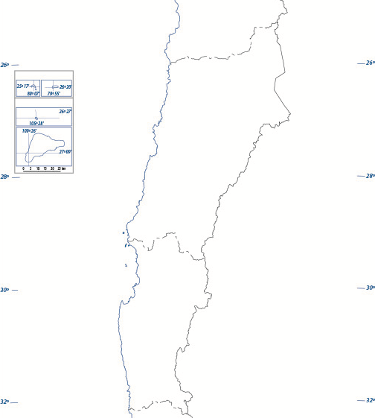

Complete el siguiente cuadro sinóptico con las características del Norte Chico que se solicita:

Ámbito | Criterio | Característica de la Zona Norte Chico
Clima | Clima (4 puntos) | __________________________________________________  __________________________________________________  __________________________________________________  __________________________________________________  __________________________________________________  __________________________________________________  __________________________________________________  __________________________________________________  __________________________________________________  __________________________________________________  __________________________________________________  __________________________________________________
Biodiversidad | Flora (4 puntos) | __________________________________________________  __________________________________________________  __________________________________________________  __________________________________________________  __________________________________________________  __________________________________________________  __________________________________________________
 | Fauna (4 puntos) | __________________________________________________  __________________________________________________  __________________________________________________  __________________________________________________  __________________________________________________  __________________________________________________  __________________________________________________
Relieve | Cordillera de los Andes (4 puntos) | __________________________________________________  __________________________________________________  __________________________________________________  __________________________________________________  __________________________________________________  __________________________________________________  __________________________________________________  __________________________________________________  __________________________________________________  __________________________________________________  __________________________________________________  __________________________________________________
 | Depresión Intermedia (4 puntos) | __________________________________________________  __________________________________________________  __________________________________________________  __________________________________________________
 | Cordillera de la Costa (4 puntos) | __________________________________________________  __________________________________________________  __________________________________________________  __________________________________________________
 | Planicies Litorales (4 puntos) | __________________________________________________  __________________________________________________  __________________________________________________  __________________________________________________
División político-administrativa | Región de Atacama (6 puntos) | Provincia | Capital
 | Región de Coquimbo (6 puntos) | Provincia | Capital

Evaluación Formativa
0 - 24 | VL | 25 - 31 | ML | 32 - 39 | L | 40 - 43 | TL

