GUIA DE INGLES: 1° MEDIO
Unit 1
Nombre Estudiante: |  |  | Curso: | Fecha:
Contenidos: | Palabras para expresar cantidad – Presente Simple – Adv. Frecuencia.

The Simple Present

We use the Simple Present to talk about habitual activities:  * I always play football in Saturdays. | We often use frequency adverbs when talking about habits:  Always – often – sometimes – hardly ever - never
Expressing quantity

For countable nouns:  A few – many | For Uncountable nouns:  A little – much
For both countable AND uncountable nouns:

Some - a lot of

I. - Complete the text using the Present Simple.

(1) _____ you _________ (like) sport? My sister (2) ___________ (love) sport. She usually (3) _________ (go) swimming on Tuesdays and Thursdays and (4) _________ (do) karate on Fridays. My friends Andrew and Keira (5) _____________ (not do) much sport. What (6) ________ they _________ (do) in their free time? They (7) _____________ (not play) football and they (8) ___________ (not do) gymnastics. They (9) ____________ (be) very lazy! Andrew often (10)____________ (chat) on the Internet and Keira (11) ___________ (write) e-mails and (12)__________ (go) shopping on-line.

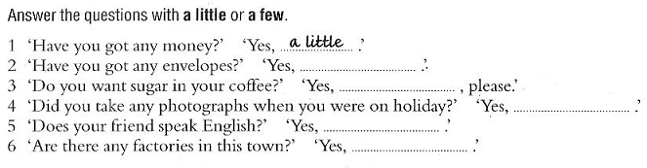

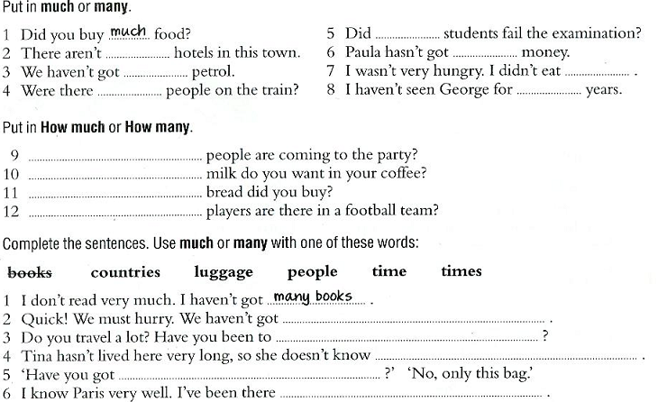

III.- Put these sentences in the correct order.
1. looking / my / for / glasses. / I’m : ____________________________________________________________________
2. are / reading? / What / you: _________________________________________________________________________
3. Pamela / is / crying? / Why: __________________________________________________________________________
4. me? / waiting / you / Are / for: _______________________________________________________________________
5. She / an / e-mail / is / writing: ________________________________________________________________________
6. driving / his / Peter / car / is: _________________________________________________________________________
7. are / They / taking / lessons / math: __________________________________________________________________________________________
8. I / cinema / go / never / to / the: ___________________________________________________________________________________________
9. and / Carlos / play / Matias / football / Saturdays. / on / always: _________________________________________________________

