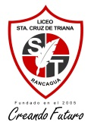

ASIGNATURA:Inglés NOMBRE DOCENTE: Erika Ramirez
OBJETIVO A LOGRAR CON LA GUÍA DE TRABAJO: Comprensión lectora

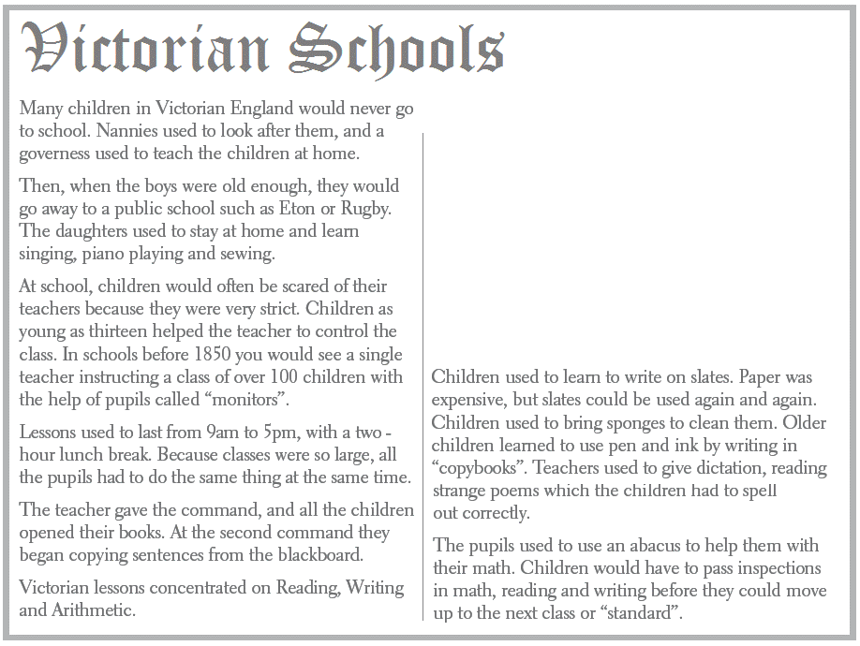

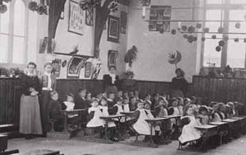

1. Que tipo de texto es?
a) a piece of news b) an advertisement c) a stract from a book.

2. Encuentra esta informacion:

- The name of 2 public schools: ______________________, ______________________.
- Time at which classes started and ended: ______________________.
- Name of students who helped teachers: ______________________.
- Subjects that students learned: _________________, _________________, _________________.

3. Veradero (T) o falso (F)?
- ______ All children in Victorian England went to school.
- ______ Girls only learned singing, sewing, and playing the piano.
- ______ Classes had a lot of students.
- ______ Victorian lessons concentrated on three areas of learning.
- ______ Students used an old type of “calculator” in math.

