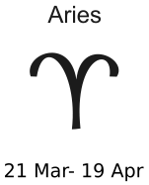  This year will be very successful for you! You will travel and met lot of new friends.  Perhaps you will meet the love of your life! |   You definitely had better years. You will have problems at school, but because you are so ambitious, you will be a winner in the end! | 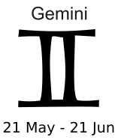  This year will be complicated. You will lose some friends but your real friends will stand by you! Winter will be dangerous for your health.
  This year your parents will try to control your life more than ever. This will make you angry, but try to listen to them. Perhaps you will benefit from their advice |   This year will bring love to your life. Be careful! Summer will be critical. And this year you will need money so start looking for a job. You’ll find it! |   This year the stars will help you at school. You will think fast and everything will seem easy. If you sudy, you will be the best in your class!
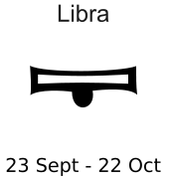  This year won’t have a very good start. Perhaps you will have problems with friends. But in summer it will turn better. |   Hungry for adventure? This will be your year! The stars will help you in troubles but try to listen to your brain too!. | 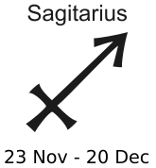  This year will bring happiness to your life. Problems that made you sad last year will end and you will feel much better and free!
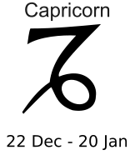  this year won’t bring you much luck. There will be some small problems in school, so be careful and patient! Try to work harder, you can! |   This will be a fun year! You’ll meet interesting people and visit interesting places, and you will have enough money! Love will also find you by the end of the year, |   chaos! This year you will often wonder why all the problems find you. Don’t worry and trust your instincts. You will always find the right way. This year will bring some romance!
This year will be very successful for you! You will travel and met lot of new friends.  Perhaps you will meet the love of your life! | You definitely had better years. You will have problems at school, but because you are so ambitious, you will be a winner in the end! | This year will be complicated. You will lose some friends but your real friends will stand by you! Winter will be dangerous for your health.
This year your parents will try to control your life more than ever. This will make you angry, but try to listen to them. Perhaps you will benefit from their advice | This year will bring love to your life. Be careful! Summer will be critical. And this year you will need money so start looking for a job. You’ll find it! | This year the stars will help you at school. You will think fast and everything will seem easy. If you sudy, you will be the best in your class!
This year won’t have a very good start. Perhaps you will have problems with friends. But in summer it will turn better. | Hungry for adventure? This will be your year! The stars will help you in troubles but try to listen to your brain too!. | This year will bring happiness to your life. Problems that made you sad last year will end and you will feel much better and free!
this year won’t bring you much luck. There will be some small problems in school, so be careful and patient! Try to work harder, you can! | This will be a fun year! You’ll meet interesting people and visit interesting places, and you will have enough money! Love will also find you by the end of the year, | chaos! This year you will often wonder why all the problems find you. Don’t worry and trust your instincts. You will always find the right way. This year will bring some romance!

