WORKSHEET – PRESENT SIMPLE
Nombre Estudiante: |  | Curso: | Fecha:

- Circle the correct words to complete the sentences.

- Most mornings, I get up / am getting up at 6.30
- Where do you work / do you working?
- I don’t understand what this word means / is meaning.
- School starts / is starting at 8.30 every day.
- Vicente always goes / go to the movies on Wednesdays.
- My brothers and I am / are good for sports.

- Rewrite each sentence as a positive or negative sentence according to the instructions. Follow the examples.

- I visit my parents very often (-)
_I don’t visit my parents very often_____________________________________
- Does he go to school every day? (+)
_He goes to school every day__________________________________________
- We watch television every night (-)
________________________________________________________________
- He doesn’t walk to work every day. (+)
________________________________________________________________
- Does she finish work after five o’clock? (+)
________________________________________________________________
- I come from Argentina (-)
________________________________________________________________
- Does he live in this street? (+)
________________________________________________________________

- Complete the sentences with one of the verbs in the box. Pay attention! Some of the verbs have to be negative!
Eat – speak – cost – teach – like – open - drink

- Margarita _____________ four languages: English, Spanish, German and French.
- I _____________ my job. It’s very boring!
- Jim _____________ a lot of Fanta. It’s his favorite drink.
- My sister is a vegetarian. She _____________ meat.
- In Chile, banks _____________ at 9.00 in the morning.
- Miss Erika _____________ English.
- Those shoes are expensive. They _____________ a ot of money.

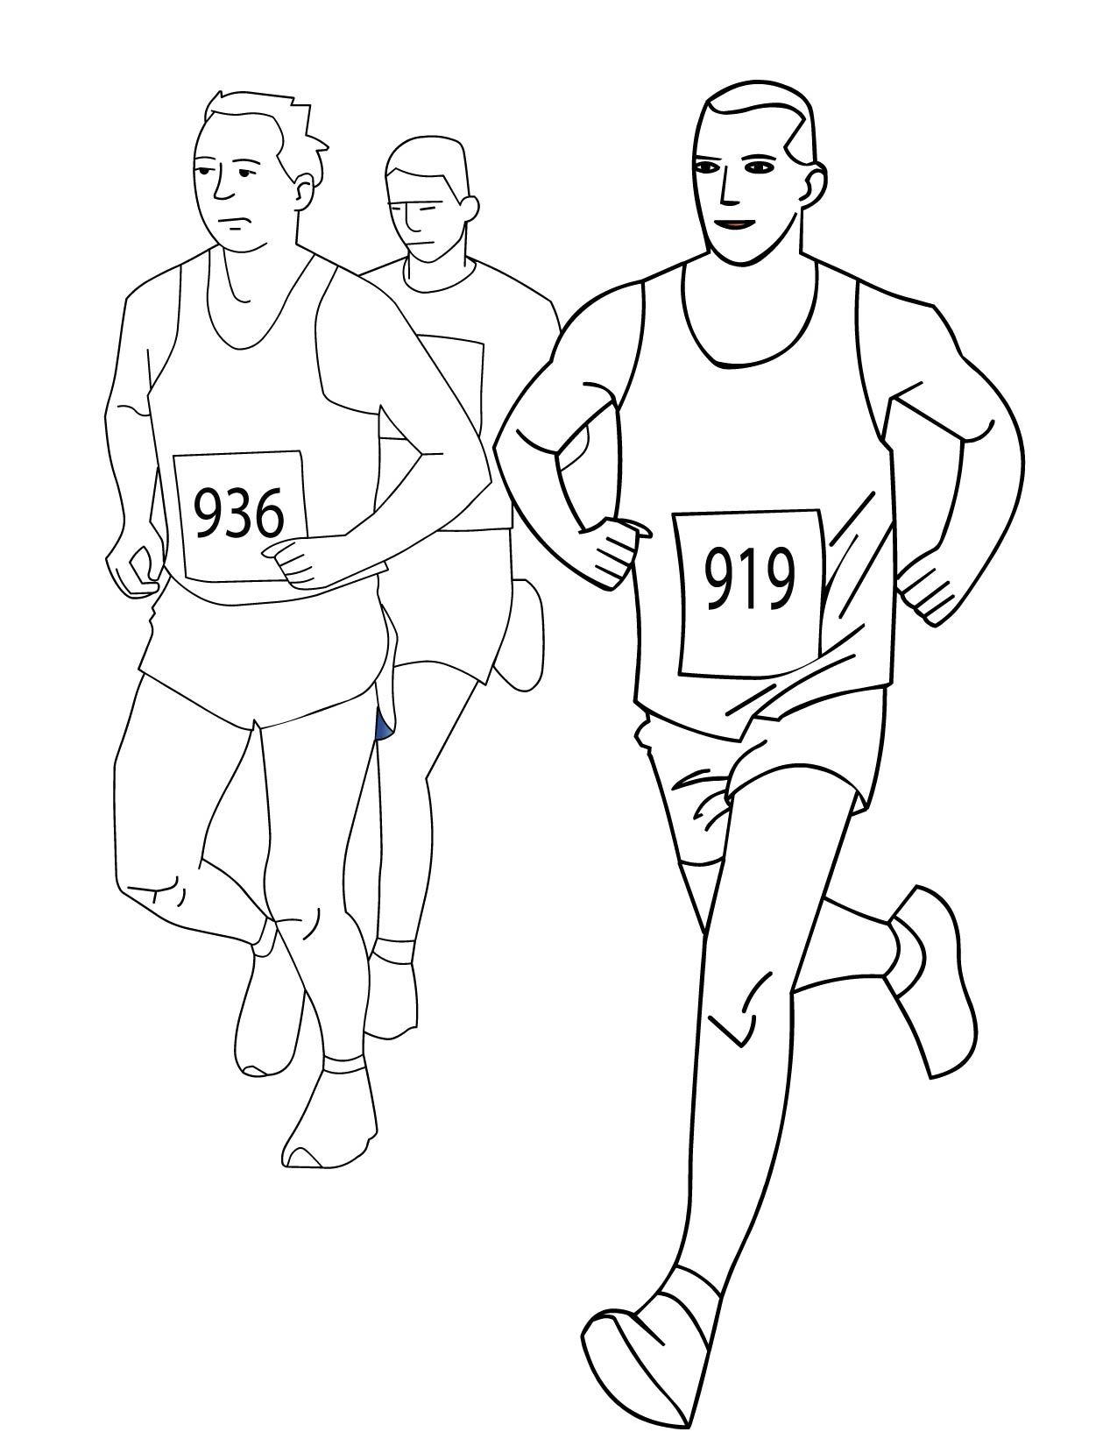
- Complete the parrgraph with the correct form of the verbs in brackets.

My name is Pedro, and I ____ (be) seventeen years old. I started running when I was nine years old. After school I ____ (go) to the club to training sessions. I usually __________ (not go) to parties because I _______ (have) to train a lot. It ______ (not be) fun, I know, but it ____ (be) for the best.
On weekends I _________ (work) in the post office. I ______ (be) a postman, and that is good because I ______ (walk) a lot. After work, my coach ______ (pick) me up and _________ (take) me to the club. He ______ (have) very good ideas and _____ (help) me a lot. He ______________ (not like) it when I _____ (get) a bit lazy. He _______ (train) me and a couple of friends. We _____ (put) a lot of effort in this sport.
I ___________ (not eat) junk food, only healthy food, in order to be stronger. I always ______ (take) care of my body, so I can be a good athlete! I usually win the races, and every now and then I come second, but I ____________ (not like) that. My dream is to win a gold medal someday.

- Complete the sentences with am/is/are or Do/don’t/doesn’t.

- Excuse me, __________ you speak English?
- Where’s Any? – I __________ know.
- What __________ yopur sister do? – she’s a dentist.
- Where __________ you come from? – Rengo.
- How much __________ it cost that cellphone?
- Jorge is a good football player but he __________ play very often.

- Write the negative of these sentences.

- I play basketball very well. ______________________________________________.
- Judy plays volleyball very well. ______________________________________________.
- They know my phone number. ______________________________________________.
- We practice everyday. ______________________________________________.
- He practices every Sunday. ______________________________________________.
- You do the same thing every day. ____________________________________________.

- Complete the sentences. All of them are negative. Use don’t / doesn’t + one of these verbs:

Cost – go – know – read – see – use - wear

- I buy a sport’s magazine every week, but sometimes I _____________ it.
- Paul has a bycicle but he _______________ very often.
- They like football but they _______________ to matches very often.
- Amanda is a skateboarder, but she _______________ her skate everyday.
- I _________________ much about sports. I’m not interested in it.
- It’s not an expensive sport. It ______________ much to get the equipment.
- Brian lives near us but we _______________ him very often.

- Complete the sentences.

- Are you hungry? – No, but _________ thirsty.
- _________ your parents? - They’re very well.
- Is Lindsay at home? - No, _________ at school.
- _________ my keys? – In the kitchen.
- Where is Pete from? - _________ Brasil or Argentina?
- Are you a teacher? – No, _________ a student.
- _________ is your cellphone? – It’s White.
- _________ is your sister? - _________ 11.

- Write short answers.
- Do you live in Rancagua? Yes, ___________________________.
- Does your father work in an office? No, ___________________________.
- Does SStephanie speaks French? No, ___________________________.
- Do you like practising football? Yes, ___________________________.
- Do you understand English? Yes, ___________________________.
- Do your grandparents visit you often? No, ___________________________.
- Do your parents live in Olivar? No, ___________________________.
- Do you like milk? Yes, ___________________________.
- Do you like rap? Yes, ___________________________.
- Do you know how to drive? No, ___________________________.
- Does your brother knows how to drive? Yes, _________________________.
- Does Tony and Carol like watching tv? No, ___________________________.
- Does your uncle play tennis? Yes, ___________________________.

- Read the questions and Claire’s answers. Then, write sentences about Claire.
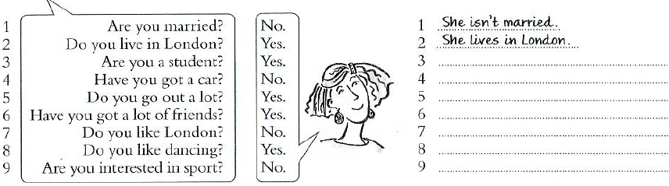

- Write sentences for the pictures. Use the words in the boxes + is / isn’t / are / aren’t.

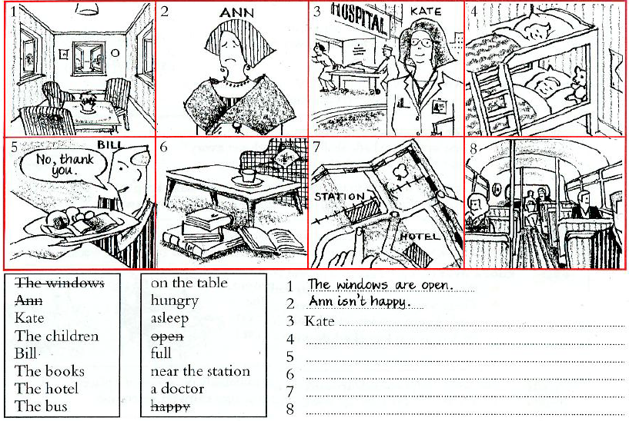

- Put the words in the correct order.
- Normally – does – he – have – for breakfast – what?
__________________________________________________________.
- Mondays – I – don’t – go – on – out.
__________________________________________________________.
- He – usually – school – goes – by bus – to
__________________________________________________________.
- Eat – why – you – seafood – don’t?
__________________________________________________________.

- Rewrite each sentence as a question.

- She comes from Germany. (?)________________________________________________.
- She goes to work by car. (?)__________________________________________________.
- She plays football every Saturday (?)___________________________________________.
- He washes his car every week (?)______________________________________________.
- They live in Coinco (?)_______________________________________________________.
- He goes to the cineman on Fridays (?)___________________________________________.
- He works in a restaurant (?)___________________________________________________.
- She gets up at five o’clock(?)___________________________________________________.

- Complete the sentences.

- __________________ at work early (Susan – arrive)
- __________________ TV everyday. (we – not – watch)
- How often __________________ your hair? (you – wash)
- I want to go to the cinema but __________________ to go. (cristian – not – want)
- __________________ near here? (Ana – Live)
- __________________ a lot of people? (Samuel – know)
- I enjoy travelling but __________________ very much (I – not – travel)
- What time __________________ in the morning? (you – get up)
- My parents are at home in the evening. __________________ very often (they – not – go out)
- __________________ work at five o’clock (Tomás – finish)
- What __________________ ? (Javier – do)
- __________________ in a hotel (he – work)

- Complete with words from the box.

Doesn’t like – don’t like – eats – eat – get up – gets up – go – goes – like - likes

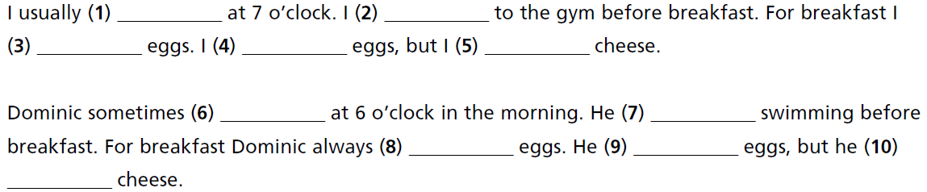

- Circle the correct word.

- Do / Does you play basketball?
- Yes I do / does.
- What time does she get / gets up?
- She usually get / gets up at 7 o’clock.
- He don’t / doesn’t like fish.
- They play / plays basketball every day.
- How often do / does she go dancing?
- She go / goes every Saturday.

- Complete the questions.
