Name: |  | Grade:  Intermediate level | Date:
Test : Describing pictures
Teacher: Miss Lucía Pereira W.
Points: | Test Points: 26 pts |  |  | Test grade:
Learning Objectives:
- Students will be able to describe in different stages a picture or piece of art.

Activity N°1: Describe the following pictures in 1st stage (4 words) and 2nd stage (2). ( 18 pts)
Picture/ Art | 1st stage | 2nd stage
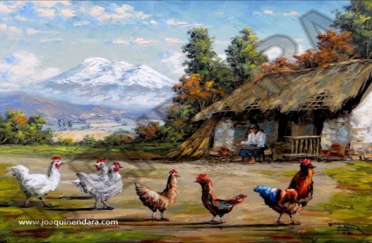  http://www.joaquinendara.com/index.html | _____________________  _____________________  _____________________  _____________________ | ________________________________  _______________________________  ________________________________  ________________________________
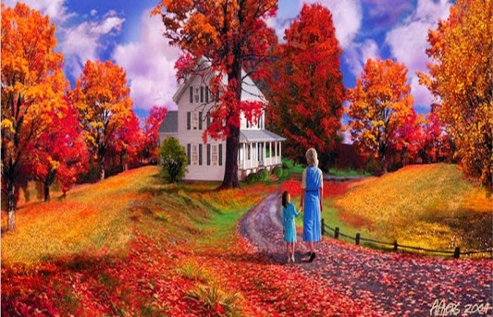  https://3.bp.blogspot.com/-3sZb9TfCM_Q/UnjJs3inZkI/AAAAAAABZeY/y0qutrBNK0Y/s1600/paisaje-al-oleo-con-personas-gentes.jpg | _____________________  _____________________  _____________________  _____________________ | ________________________________  _______________________________  ________________________________  ________________________________
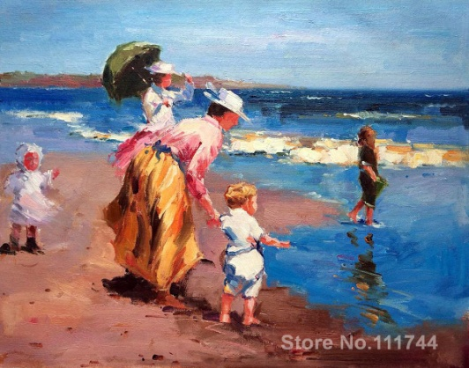  https://pt.wahooart.com/A55A04/w.nsf/O/BRUE-8LHS68 | _____________________  _____________________  _____________________  _____________________ | ________________________________  _______________________________  ________________________________  ________________________________

Activity N°2: According to the description, select the right image. ( 2 pts)
“In the picture, there are people in a park. They are happy. Also, there is on boy sitting on and there is one man doing the barbecue. There are some clouds, too. I can see a lake behind and some short pine trees. It´s a sunny day!”
https://es.123rf.com/photo_44844359_ni%C3%B1os-jugando-en-el-parque-en-la-ilustraci%C3%B3n-d%C3%ADa.html
https://www.freepik.es/vector-gratis/familia-ilustracion-picnic-barbacoa-diseno-dibujos-animados-hombre-padre-freir-parrilla-barbacoa_3090653.htm
https://www.istockphoto.com/es/vector/grupos-de-personas-en-el-picnic-barbacoa-familias-felices-en-varias-actividades-al-gm950680060-259495371
a) b) c)
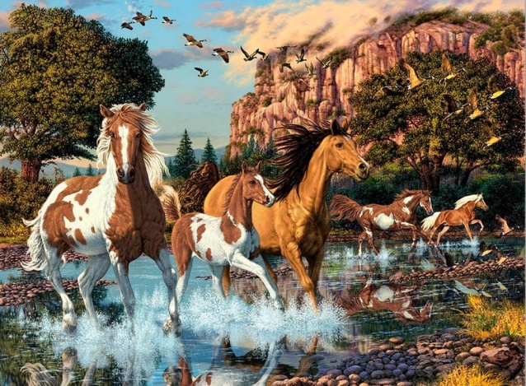
Activity N°3: Choose one picture and describe in 3rd stage: 3 full sentences using adjectives. ( 6pts)
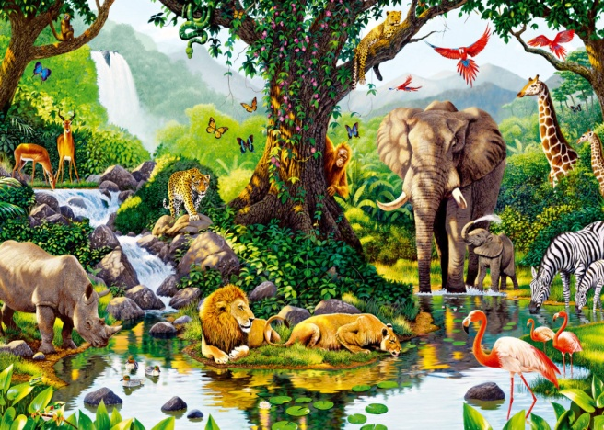
https://bild-paisajes.blogspot.com/2019/02/paisajes-con-caballos-corriendo-en-el.html
https://www.pinterest.co.kr/pin/456763587183611916/?lp=true

