- MINEDUC’S BOOK UNIT 2- EDUCATION AND LIFELONG LEARNING 1°G

- TRANSLATE THE SENTENCES
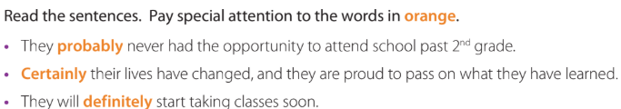

- READ AND GET THE MAIN IDEAS
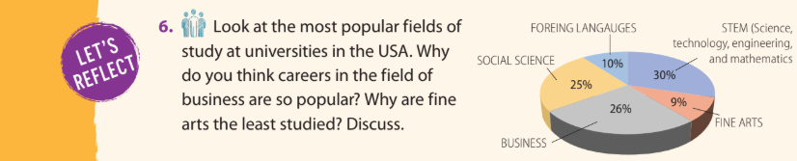

- LOOK FOR THEIR DEFINITIONS
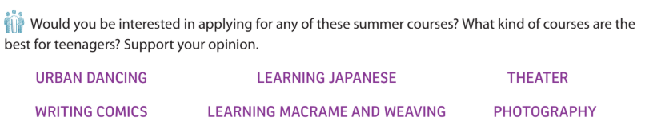

- WRITE THE SAME TEXT IN ENGLISH PLEASE

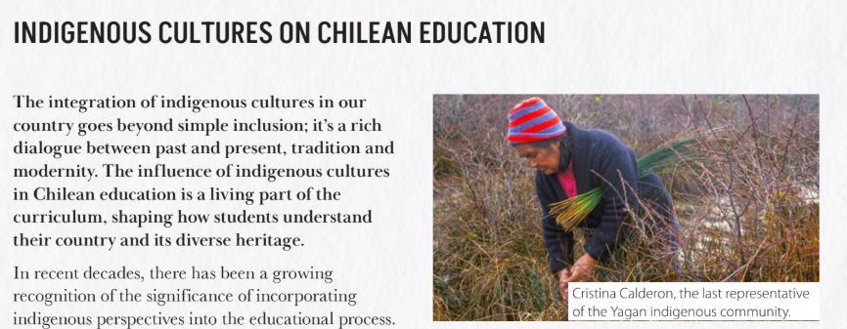

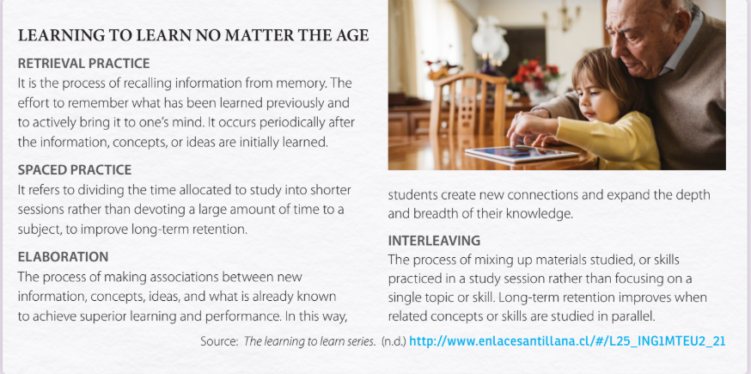
- TRANSLATE

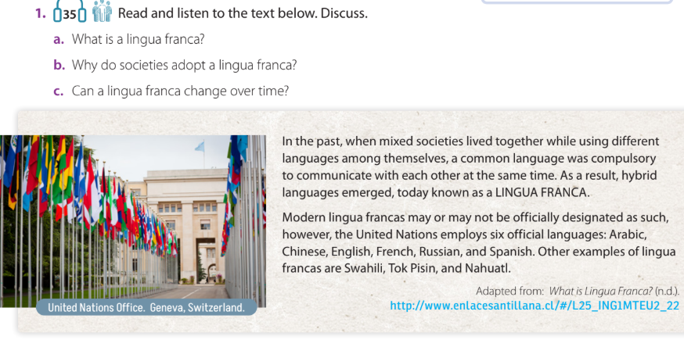
- READ AND ANSWER



