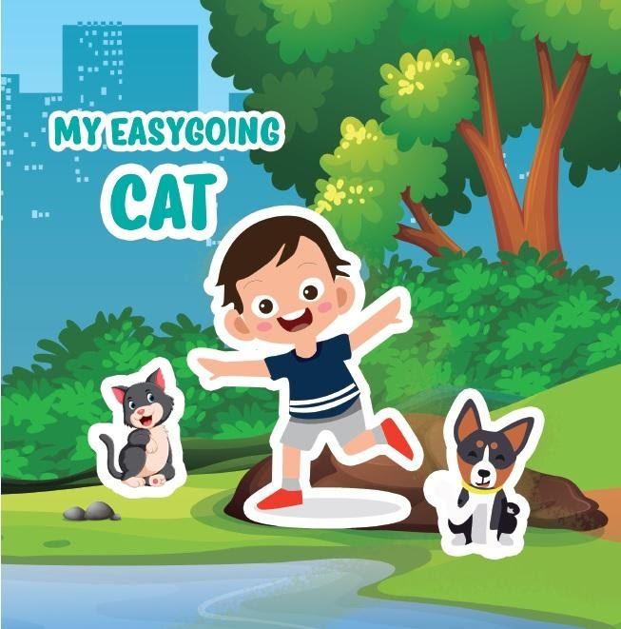
LINKS DE MATERIAL DESCARGABLE HISTORIA CORTA “MY EASYGOING CAT”

- CUENTO EN PDF DESCARGABLE

https://drive.google.com/file/d/1_gKX1R-tRc-8tQp1QAFCghnBuNDCbgdW/view?usp=sharing

- GUÍAS DEL ESTUDIANTE
https://docs.google.com/document/d/1ACwzLpk6nor_IIg57-bIklgbJSWEcj8D/edit?usp=sharing&ouid=104727592199537278606&rtpof=true&sd=true

- AUDIO CUENTACUENTOS
https://drive.google.com/file/d/1PHekgf_4qDr277AyL8uwEX0EJ-VvdSmh/view?usp=sharing

