DICTADO DE ORACIONES.

NOMBRE:________________________________________CURSO________

1) _________________________________________________

2) __________________________________________________

3) __________________________________________________

4) ______________________________________________________

5) __________________________________________________

6) __________________________________________________

7) ________________________________________________

ESCRITURA ESPONTÁNEA:

_______________________________________________________________
_______________________________________________________________
_______________________________________________________________
_______________________________________________________________

_______________________________________________________________

_______________________________________________________________

_______________________________________________________________

DICTADO DE ORACIONES.

NOMBRE:________________________________________CURSO________

1) ______________________________________________

2) __________________________________________________

3) _____________________________________

4) __________________________________________________

5)_________________________________________________

6)_______________________________________________

7) _______________________________________________

8) ______________________________________________

9) ___________________________________________

10)________________________________________________

11) __________________________________________________

12) ______________________________________________

13) _______________________________________________

14) __________________________________________

DICTADO DE ORACIONES.

NOMBRE:________________________________________CURSO________

1) _________________________________________________

2)__________________________________________________

3)___________________________________________________

4) ------------------------------------------------------------------------------

5________________________________________________

6) _______________________________________________

7) _____________________________________________

ESCRITURA ESPONTÁNEA:

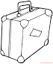

_______________________________________________________________
_______________________________________________________________
_______________________________________________________________
_______________________________________________________________

_______________________________________________________________

_______________________________________________________________

_______________________________________________________________

_______________________________________________________________

ESCRITURA ESPONTÁNEA:

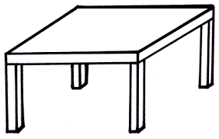

_______________________________________________________________
_______________________________________________________________
_______________________________________________________________
_______________________________________________________________

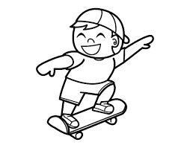

_______________________________________________________________

_______________________________________________________________

_______________________________________________________________

_______________________________________________________________

Guía Escritura de Oraciones

Nombre: .…………………………………………. Fecha………………

 

 

